Pre-Terminated BNC Video and DC Power Shotgun Cable Extension Cable Lead for CCTV Security Camera DVR System - 25 Meter

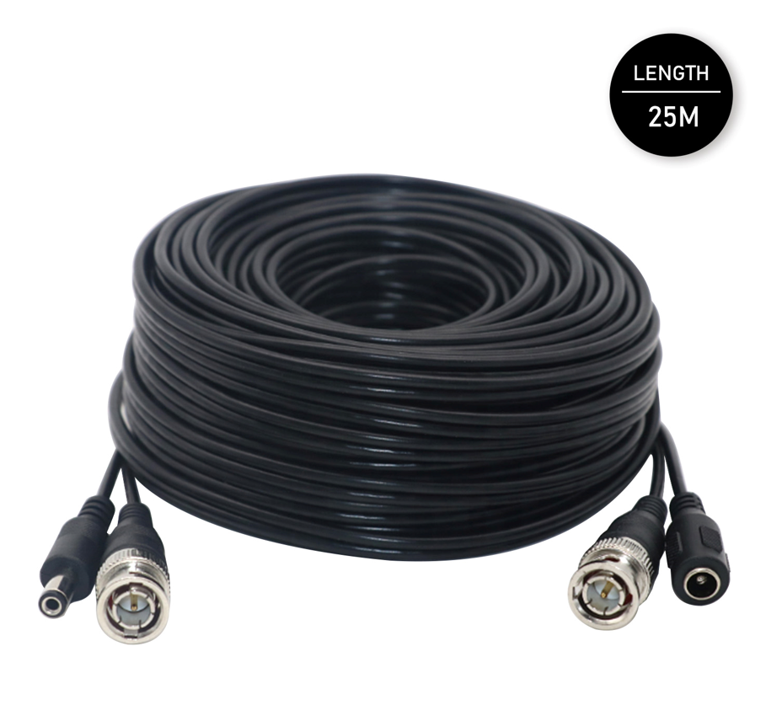

About this item
- ✔️ EASY TO INSTALL | Want to quickly install, deploy or re-route your CCTV cameras, DVRs or other compatible equipment without the fuss of terminating BNC cables or running separate DC power?
- ✔️ JUST THE SIZE THAT YOU ARE LOOKING FOR | Available in three (3) popular lengths of 18 metres, 25 metres and 50 metre lengths allow anyone to quickly install common, BNC CCTV cameras without the expensive and time consuming terminating of plugs etc.
- ✔️ HIGH QUALTY & STURDY MATERIAL | Using standard 75-Ohm coax and quality BNC, the shotgun cable has a dedicated cable which allows DC power to be fed to remote CCTV cameras, DVRs, set-top boxes and other compatible equipment for both retail and professional security and broadcast applications.
- ✔️ INDOOR & OUTDOOR | Weather-resistant, durable and of course lightweight and being a shotgun design means your just pulling one, low overall diameter cable which means a much reduce install time.
- ✔️ 100% SATISFACTION GUARANTEE: We strive to provide quality products and services. While our products are made of high-quality material, should you have any issue with your purchase, we provide a 2-year warranty. Feel free to contact us. Your happiness with your purchase is our #1 priority.

Product Specifications
Compatible Devices | Security Camera , Camera
Connector Type | RF Connector
Ean | 5060808387630
Model Number | C-BNC-25M
Part Number | C-BNC-25M
Size | 25 Meter

Specification for this product family
Brand Name | LMS DATA

Technical Details
Manufacturer | ‎Dynamode
Part number | ‎C-BNC-25M
Item Weight | ‎506 g
Package Dimensions | ‎21.5 x 19.5 x 5.4 cm; 506 Grams
Item model number | ‎C-BNC-25M
Size | ‎25 Meter
Batteries included? | ‎No
Batteries Required? | ‎No

